**Full Stack Development with MERN**

**Project Documentation format**

**\*. Introduction**

* **Project Title:** **“BestBooks”**
* **Team Members:**

M AKSHAI (Team Lead),

P VENKATARAO,

P MADHUSUDHAN,

K KIRAN.

**\*. Project Overview**

* **Purpose:**

# **BestBooks is a online books store where you can find books for the customer’s well suited books.**

# **In libraries, bookstores, and personal book collections, managing books efficiently is a challenging task.**

# **Traditional book management system often lack real-time tracking, personalized recommendations and seemless user experience.**

# **Readers struggle to find relavent books, track borrowed and purchased books and receive suggetions based on their interests.**

* **Features:**

# **People can add their books to sell by creating their seller accounts.**

# **The BestBooks aims to create a user-friendly platform that specifies the process of organizing books.**

# **It will serve as a digital book shelf for readers to easily manage their wishlists, while also giving independent authors to increase their publishing oppurtunities.**

# **This is a best place for readers and book enthusiasts to get more books to read.**

# **Admin can delete any user’s or seller’s account if there is any disturbance**

# **BestBooks will help sellers gain money and users get good books to read.**

Effortlessly purchase or reserve books for pickup at your convenience.

Tailored for the modern book enthusiast, our MERN-based Book-Store Application seamlessly blends robust functionality with an intuitive user interface.

**\*. Architecture**

#### **Frontend:** **React Architecture**

The frontend of the application is built using **React**, a popular JavaScript library for building user interfaces, specifically single-page applications (SPA). The React architecture is based on components and state management, which provides a modular and maintainable structure.

1. **Component-Based Structure**:
   * **Functional Components**: The app is structured into small, reusable, and testable functional components. Each component handles a specific UI element, such as a button, form, or table.
   * **Class Components (if necessary)**: Older components or those requiring lifecycle methods may use class components, although functional components with hooks are the preferred approach in modern React development.
   * **Container and Presentational Components**:

Containers handle logic and state management, while presentational components focus on the UI and rendering. This division improves readability and maintainability.

1. **State Management**:
   * **React's useState and useEffect**:

Local component states are managed with useState and lifecycle events with useEffect. These hooks help to handle user interactions, manage form inputs, and make API calls.

* + **Context API / Redux (Optional)**:

For larger applications or more complex state requirements, **Context API** or **Redux** can be used for global state management. Redux helps in managing state in a more scalable way, especially when passing data between many components.

1. **Routing**:
   * **React Router**: This library is used for managing routes and navigation. It allows the application to have multiple views while maintaining a single-page application experience, which ensures that the page doesn't reload when navigating between routes.
2. **Styling**:
   * **CSS-in-JS (Styled-components)**: For styling the components, **Styled-components** or **Emotion** can be used. These allow scoped CSS for each component, ensuring that styles don’t conflict.
   * Alternatively, **CSS modules** or **Sass** may be used for more traditional CSS handling.
3. **API Calls**:
   * **Axios API**: Axios is used to make HTTP requests to the backend. The frontend communicates with the backend API to send and retrieve data.

#### **Backend:** Node.js and Express.js Architecture

The backend of the application is built using **Node.js** for server-side runtime and **Express.js** as a web framework. The server handles routing, authentication, business logic, and database interactions.

1. **Node.js**:
   * **Event-Driven Architecture**: Node.js is built on a non-blocking, event-driven architecture, making it ideal for handling multiple concurrent requests. Its asynchronous nature helps in building scalable systems.
   * **Single-Threaded**: Despite being single-threaded, Node.js can handle multiple requests efficiently using the event loop, making it great for I/O-bound tasks like handling HTTP requests, reading/writing from databases, etc.
2. **Express.js**:
   * **Routing**: Express.js is used to define routes for different endpoints of the application. The routes handle incoming requests, process them, and send responses back to the client.
   * **Middleware**: Express uses middleware functions to process requests before they reach the route handler. Middleware can be used for logging, authentication, error handling, and request parsing.
   * **Authentication**: Express can integrate with **JWT (JSON Web Token)** or **OAuth** for authentication and authorization purposes. Middleware functions handle token validation for secure endpoints.
   * **RESTful API Design**: The API is designed using REST principles, with endpoints corresponding to CRUD (Create, Read, Update, Delete) operations. Each route corresponds to a specific resource.
3. **Request Handling**:
   * **HTTP Methods**: Express routes handle various HTTP methods such as GET, POST, PUT, DELETE to manage different operations on resources.
   * **Error Handling**: Global error handling middleware is implemented to catch errors across the entire application and provide consistent error responses.

Database: MongoDB

The application uses **MongoDB** as the NoSQL database to store and retrieve data. MongoDB is chosen for its flexibility and scalability in handling unstructured or semi-structured data.

1. **Schema Design**:
   * **Collections**: Data is stored in collections (similar to tables in SQL databases). Each collection contains documents that represent data objects.
   * **Schema Definition**: Using **Mongoose**, a MongoDB ODM (Object Data Modeling) library, schemas are defined for the different entities in the application. Each schema defines the structure of the documents within a collection.

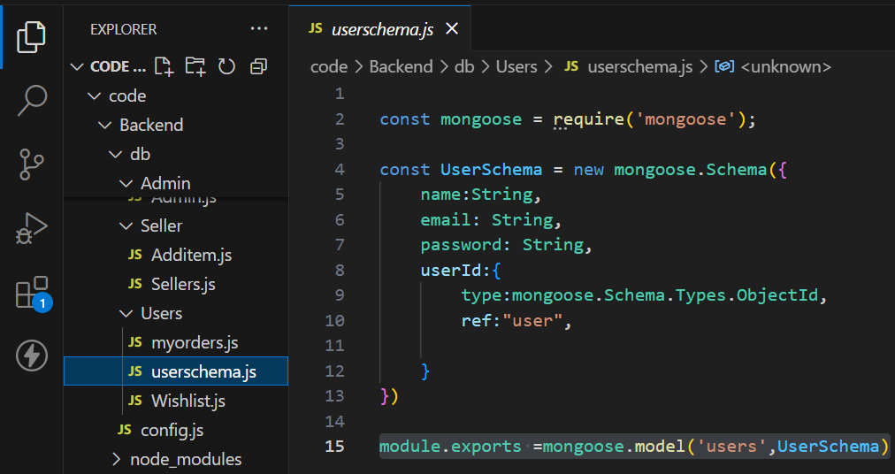

1. **Data Interactions**:

* **CRUD Operations**: Express routes interact with the database using Mongoose methods like create(), find(), update(), and delete().
  + Example of fetching a user from the database:

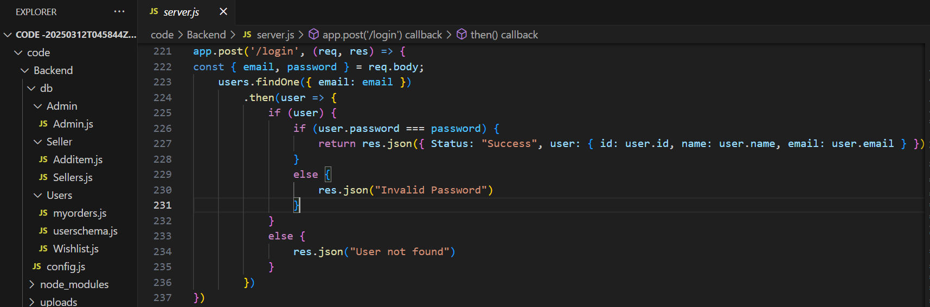

. **Data Validation**: Mongoose schema allows setting validation rules (e.g., required fields, unique constraints) to ensure data integrity before it is saved to the database.

1. **Indexes**:Indexes are defined on frequently queried fields (like username, email, etc.) to improve query performance. Mongoose supports indexing through the index() method or unique constraints on certain fields.
2. **Database Connection**:**Mongoose** is used to connect the Node.js application to the MongoDB database. The connection is established at the beginning of the server lifecycle using:

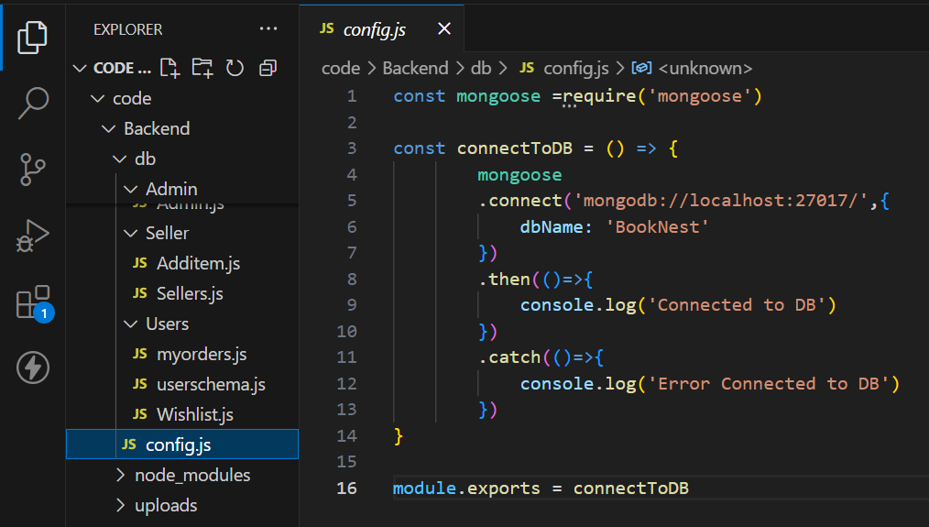

**\*. Setup Instructions:**

**Prerequisites and Installations:**  To develop a full-stack Book Store App using React js, Node.js,Express js and MongoDB, there are several prerequisites you should consider. Here are the key prerequisites for developing such an application:

**Node.js and npm:** Install Node.js, which includes npm (Node Package Manager), on your development machine. Node.js is required to run JavaScript on the server side.

• Download: <https://nodejs.org/en/download/>

•Installation instructions:

<https://nodejs.org/en/download/package-manager/>

**MongoDB:** Set up a MongoDB database to store hotel and booking information. Install MongoDB locally or use a cloud-based MongoDB service.

• Download:

<https://www.mongodb.com/try/download/community>

• Installation instructions:

<https://docs.mongodb.com/manual/installation/>

**Express.js:** Express.js is a web application framework for Node.js. Install Express.js to handle server-side routing, middleware, and API development.

• Installation: Open your command prompt or terminal and run the following

   command: **npm install express**

**React js: React** is a JavaScript library for building client-side applications.

 And Creating Single Page Web-Appliaction

**Getting Started:**

Create React App is an officially supported way to create single-page React applications. It offers a modern build setup with no configuration.

**Quik  Start:**

npm create vite@latest

cd my-app

npm install

npm run dev

If you've previously installed create-react-app globally via npm install -g create-react-app, we recommend you uninstall the package using npm uninstall -g create-react-app or yarn global remove create-react-app to ensure that npx always uses the latest version.

**Create a new React project:**

• Choose or create a directory where you want to set up your React project.

• Open your terminal or command prompt.

• Navigate to the selected directory using the cd command.

• Create a new React project by running the following command: npx create-react-app your-app-name.Wait for the project to be created:

• This command will generate the basic project structure and install the necessary dependencies

**Navigate into the project directory:**

• After the project creation is complete, navigate into the project directory by running the following command**: cd your-app-name**

**Start the development server:**

• To launch the development server and see your React app in the browser, run the following command: **npm run dev**

• The npm start  will compile your app and start the development server.

• Open your web browser and navigate to <https://localhost:5173> to see your React app.

You have successfully set up React on your machine and created a new React project. You can now start building your app by modifying the generated project files in the src directory.

Please note that these instructions provide a basic setup for React. You can explore more ad- vanced configurations and features by referring to the official  React documentation: <https://react.dev/>

**HTML, CSS, and JavaScript:** Basic knowledge of HTML for creating the structure of your app, CSS for styling, and JavaScript for client-side interactivity is essential.

**Database Connectivity:** Use a MongoDB driver or an Object-Document Mapping (ODM) library like Mongoose to connect your Node.js server with the MongoDB database and perform CRUD (Create, Read, Update, Delete) operations.

**Front-end Library:** Utilize React  to build the user-facing part of the application, including products listings, booking forms, and user interfaces for the admin dashboard.

**Version Control**: Use Git for version control,

• Git: Download and installation instructions can be found at:<https://git-scm.com/downloads>

**Development Environment:**

• Visual Studio Code: Download from <https://code.visualstudio.com/download>

• Sublime Text: Download from

<https://www.sublimetext.com/download>

• WebStorm: Download from <https://www.jetbrains.com/webstorm/download>

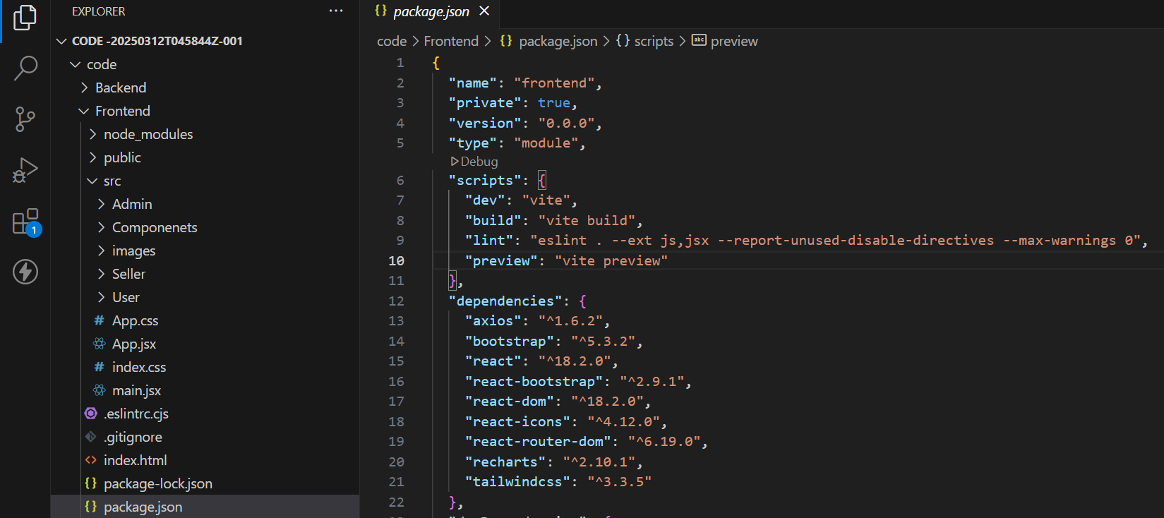

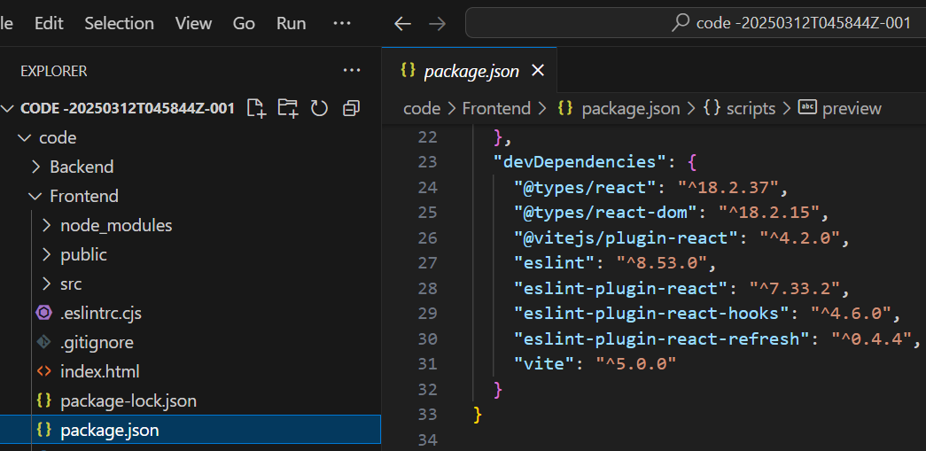

**\*. Folder Structure**

* **Client (Frontend) Structure:**

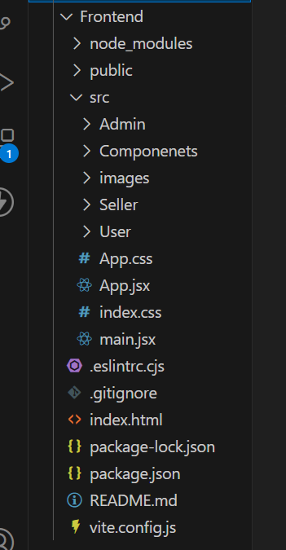

* This is the folder structure of Frontend folder.
* **Server (Backend) Structure:**

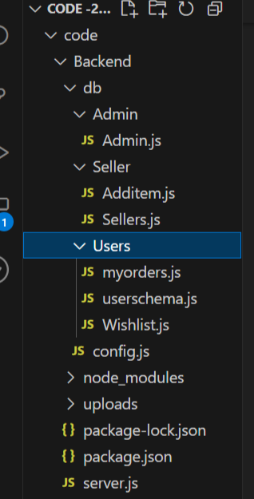

* This is the folder structure of Backend folder.

**\*. Running the Application:**

* The commands to start the frontend and backend servers locally are :
  + **Frontend:** npm run dev in the Frontend directory.
  + **Backend:** npm start in the Backend directory.

**\*. API Documentation**

1. **Create a new user account:**

• **Endpoint**: /signup

• **Method**: POST

• **Description**: This endpoint is used to create a new user in the database.

• **Response**: Status:200 OK

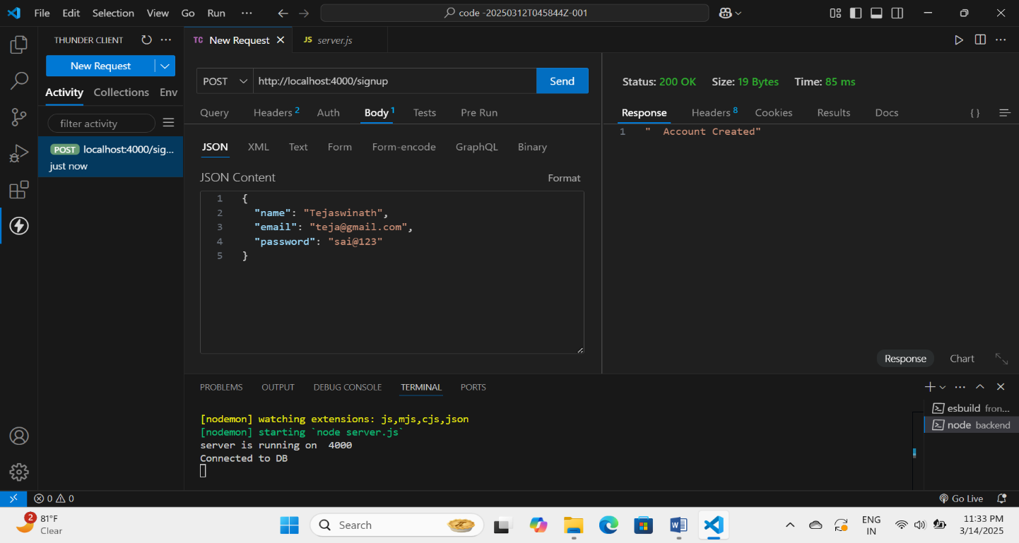

**2. Login to the user account:**

• **Endpoint**: /login

• **Method**: POST

• **Description**: This endpoint is used to log into user account.

• **Response**: Status:200 OK

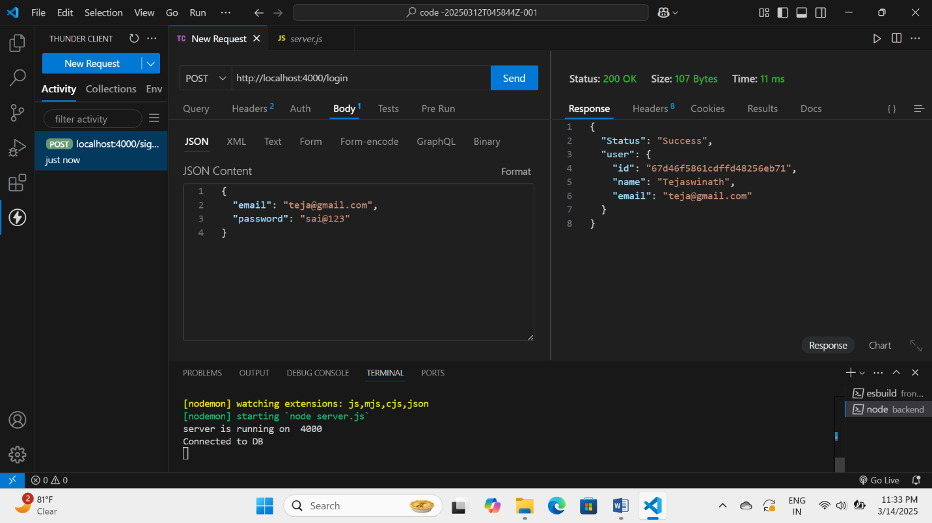

**3. Create a new seller account:**

• **Endpoint**: /ssignup

• **Method**: POST

• **Description**: This endpoint is used to create a new seller in the database.

• **Response**: Status:200 OK

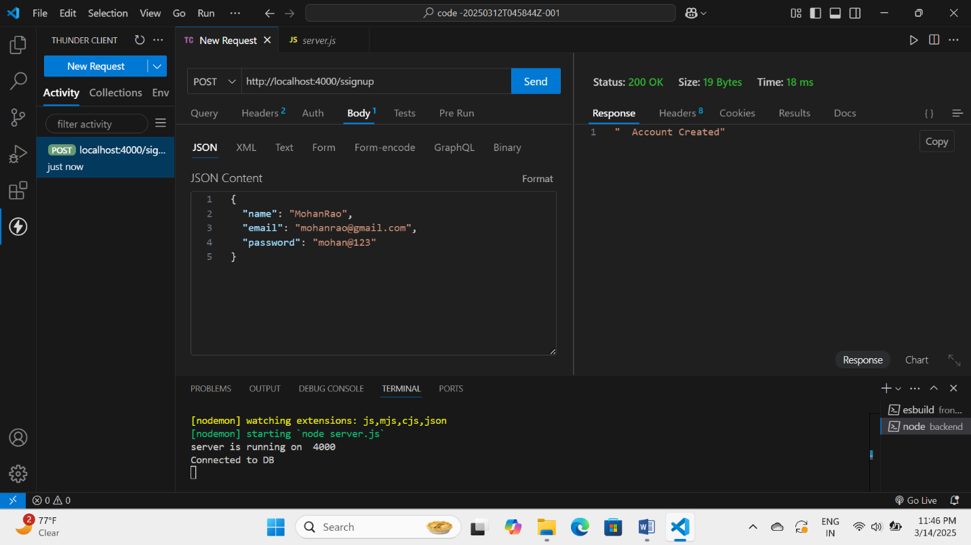

**4. Login to the seller account:**

• **Endpoint**: /slogin

• **Method**: POST

• **Description**: This endpoint is used to log into seller account.

• **Response**: Status:200 OK

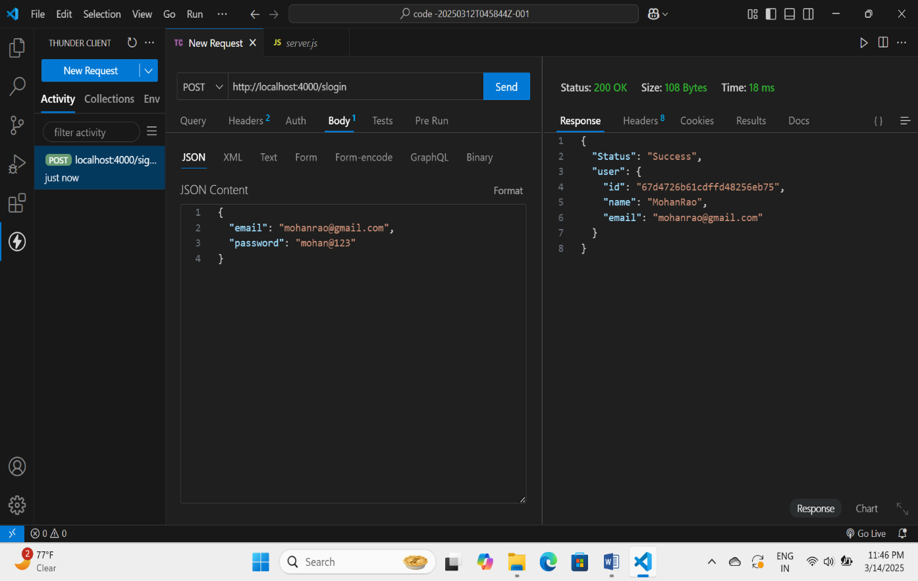

**5. Create a new admin account:**

• **Endpoint**: /asignup

• **Method**: POST

• **Description**: This endpoint is used to create a new admin in the database.

• **Response**: Status:200 OK

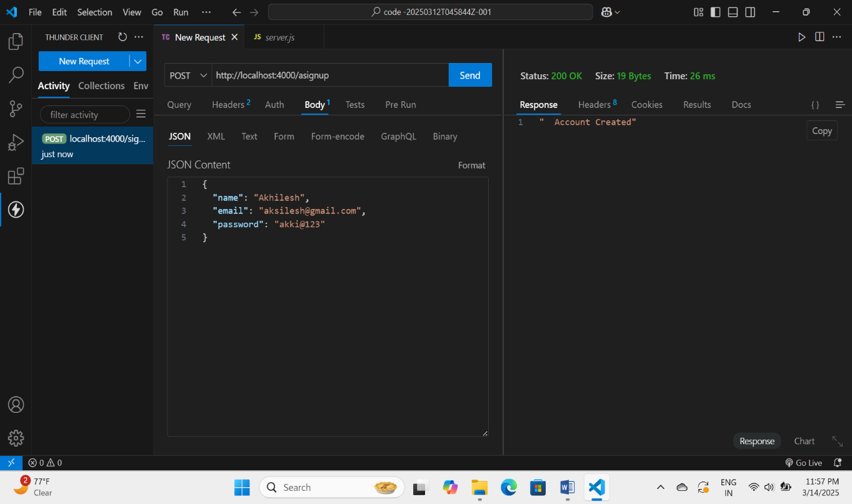

**6. Login to the admin account:**

• **Endpoint**: /alogin

• **Method**: POST

• **Description**: This endpoint is used to log into admin account.

• **Response**: Status:200 OK 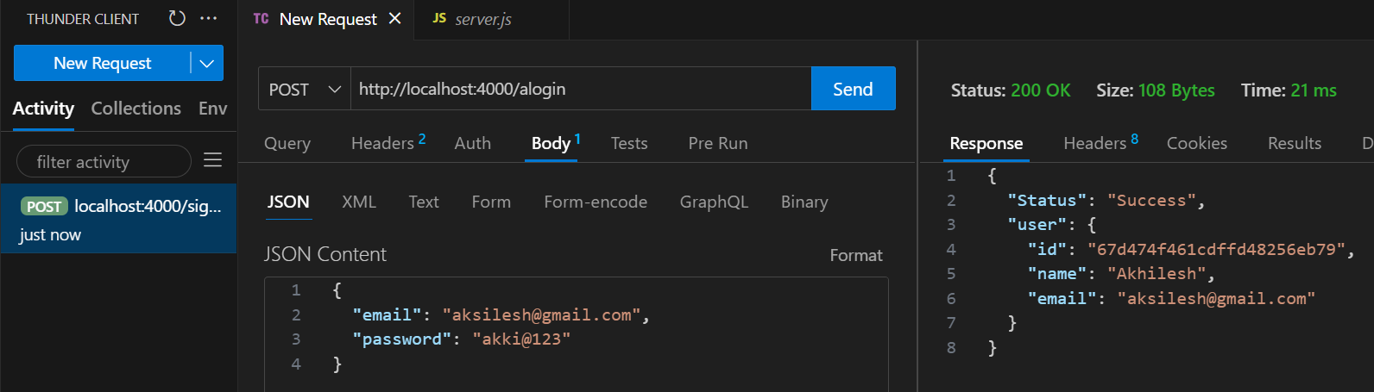

**\*. Authentication:**

Authentication is handeled using JWT tockens.

**Example:**

const jwt = require('jsonwebtoken');

const auth = (req, res, next) => {

const token = req.cookies.token;

if (!token) return res.status(401).json({ message: 'Unauthorized' });

jwt.verify(token, process.env.JWT_SECRET, (err, user) => {

if (err) return res.status(403).json({ message: 'Forbidden' });

req.user = user;

next();

});

*. **User Interface:**

1. Home page – It is a books store application where users click the user icon.

2. User Home page – Here user can see some book pictures and which ever they press , it takes them to the Books page.

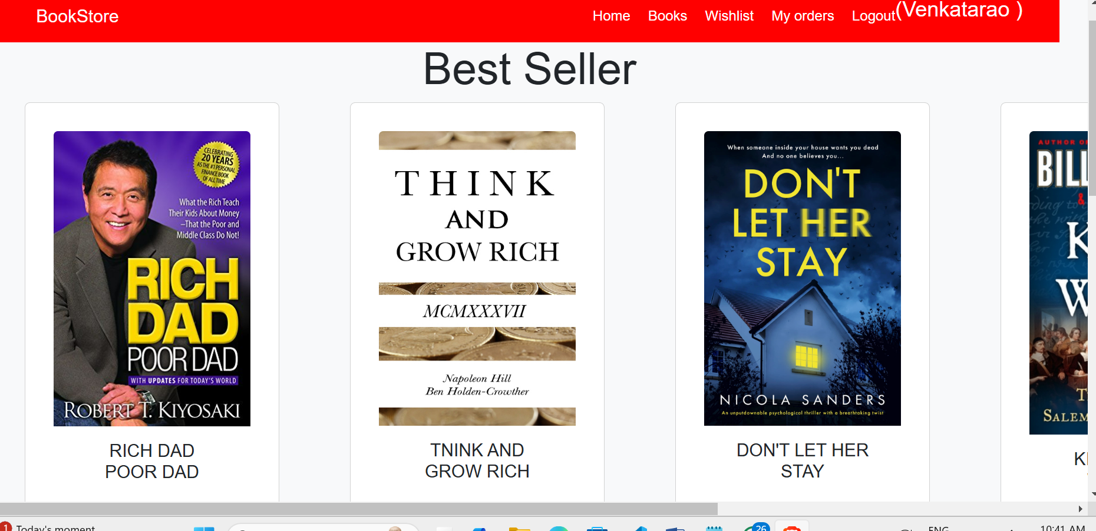

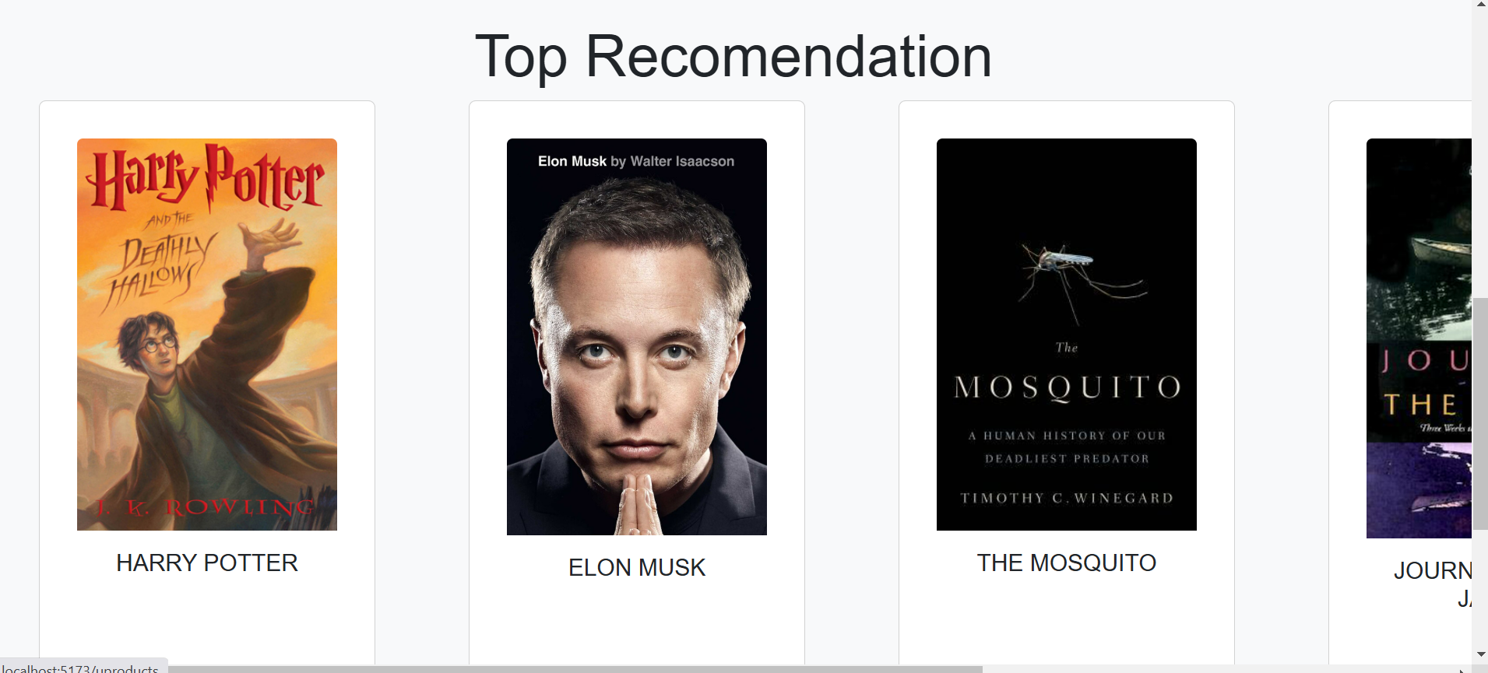

3.Books page – Here the books that seller uploaded were shown.

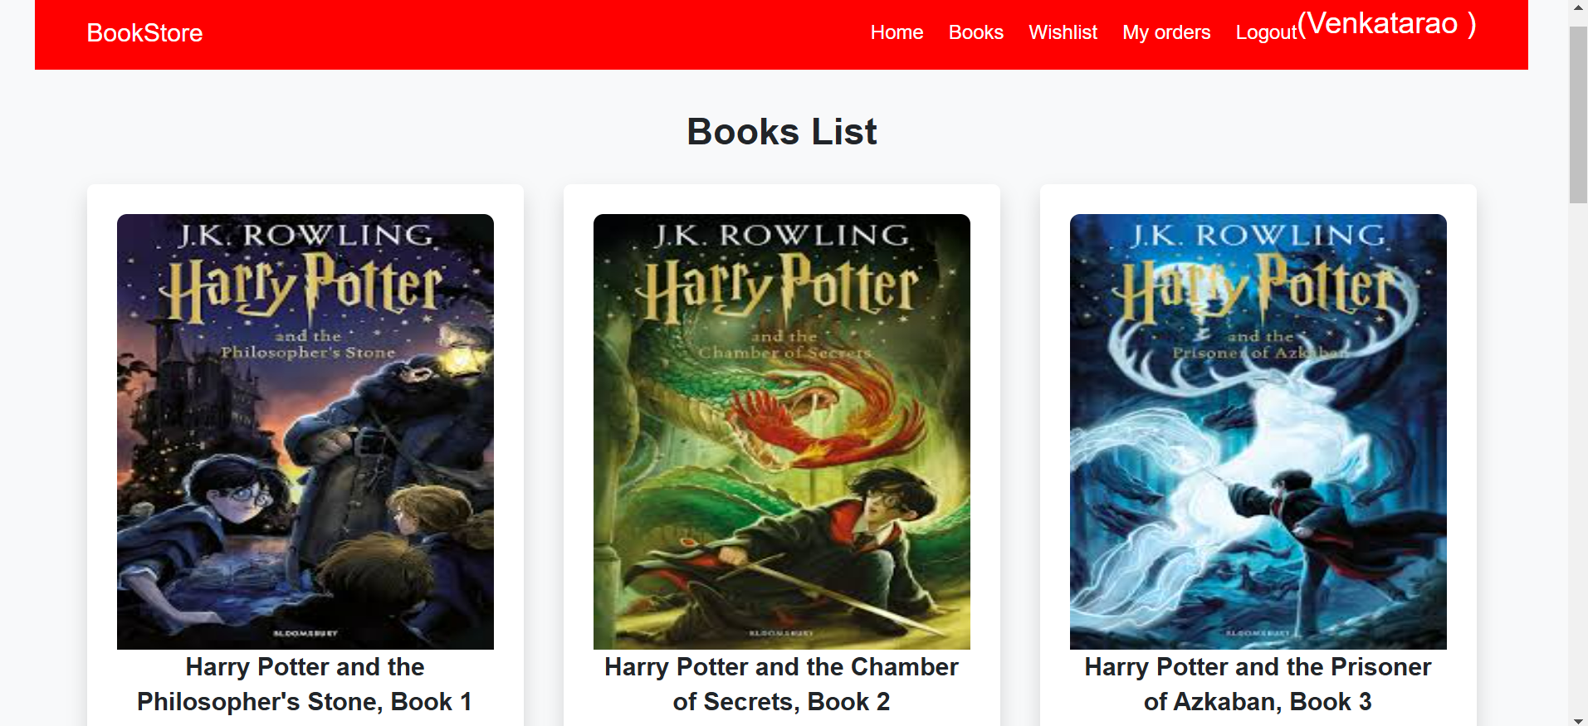

1. Wishlist – Here the books that user wished to buy were kept in this page.

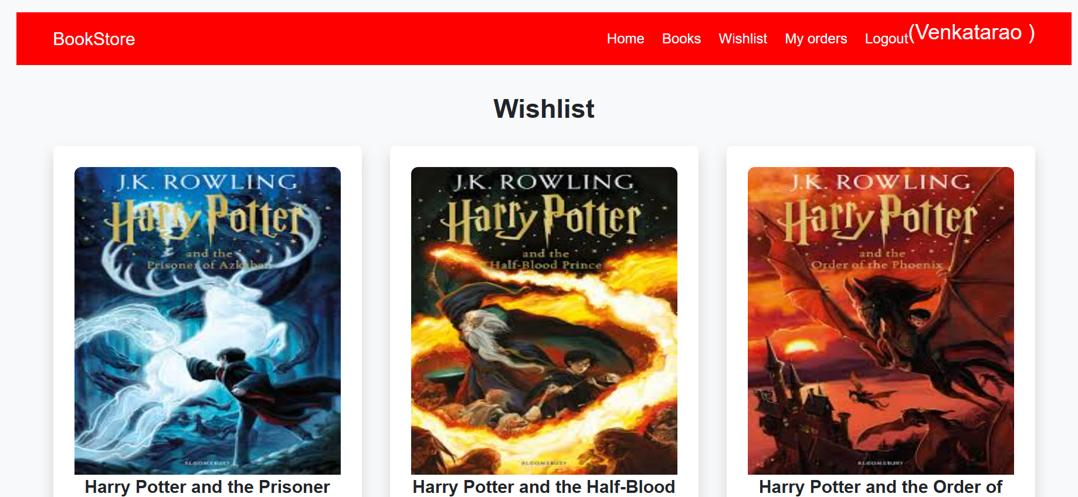

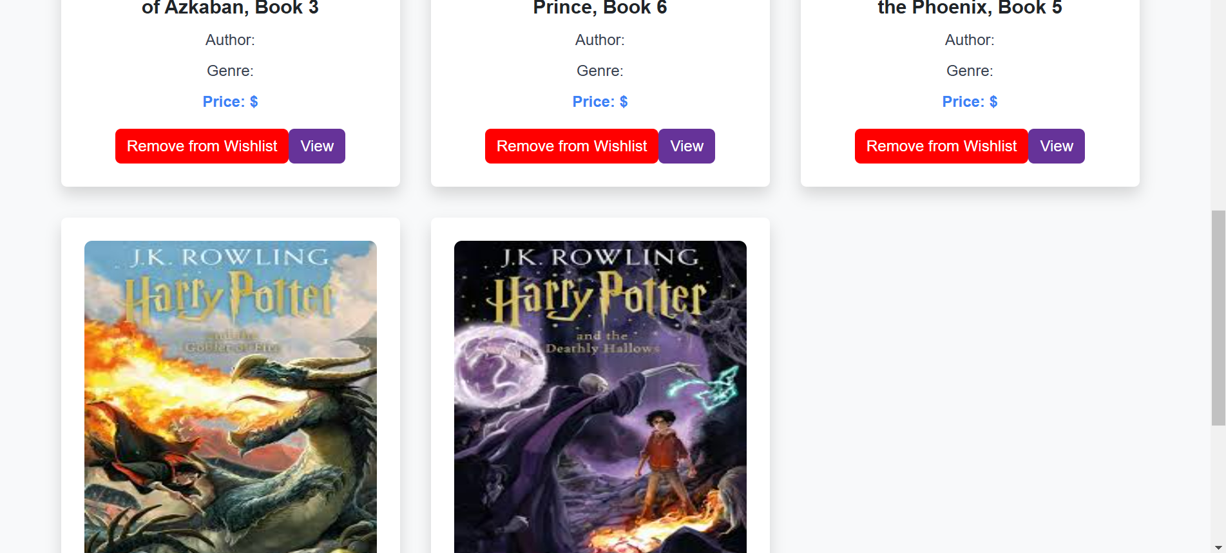

\***. Known issues:**

The payment gateway integration is under development.

**\*. Testing:**

Backend: Using Postman and Thunderclient for API testing.

Frontend: Using React Testing Library.

**\*. Screenshot of the running application:**

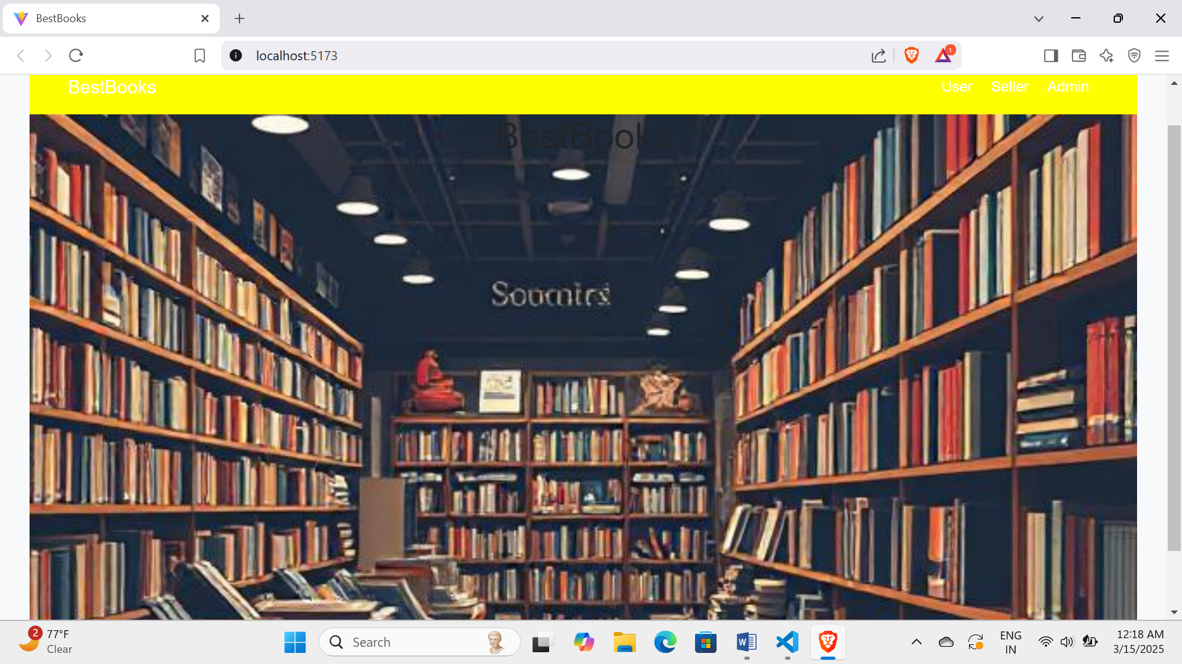

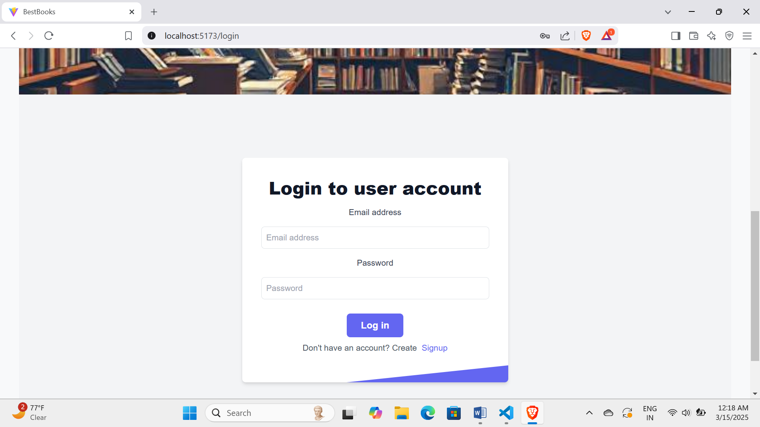

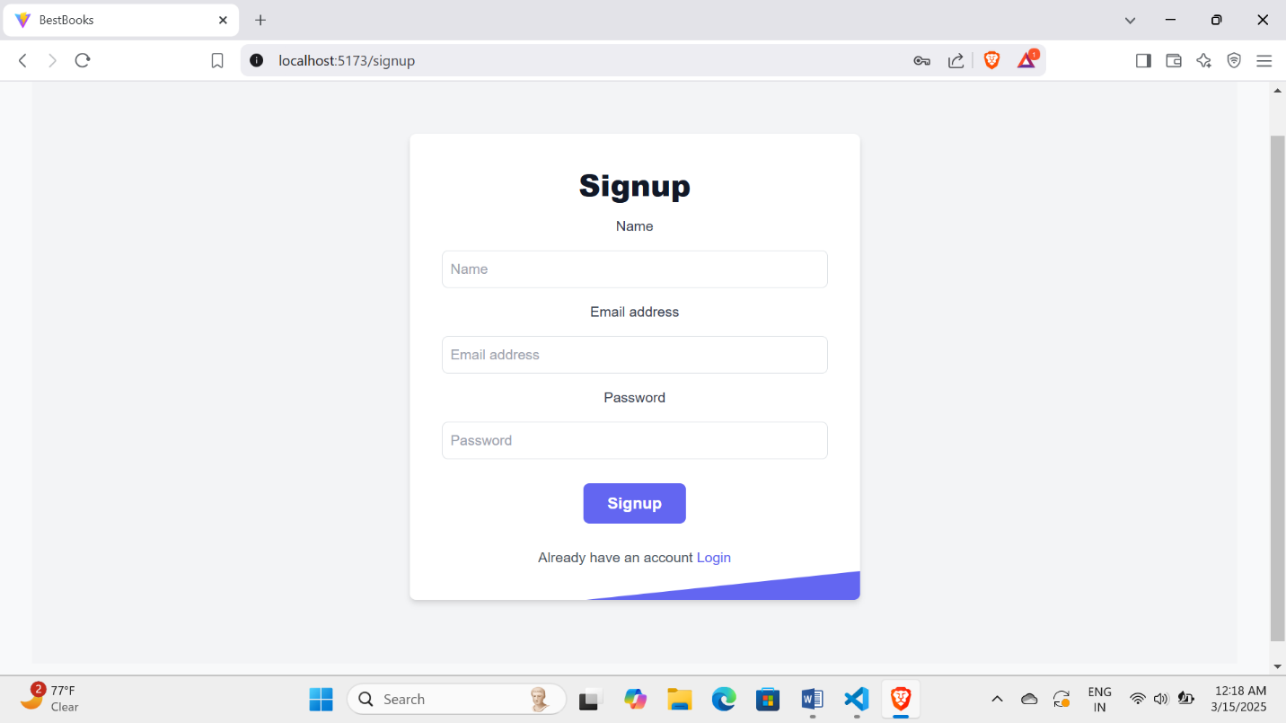

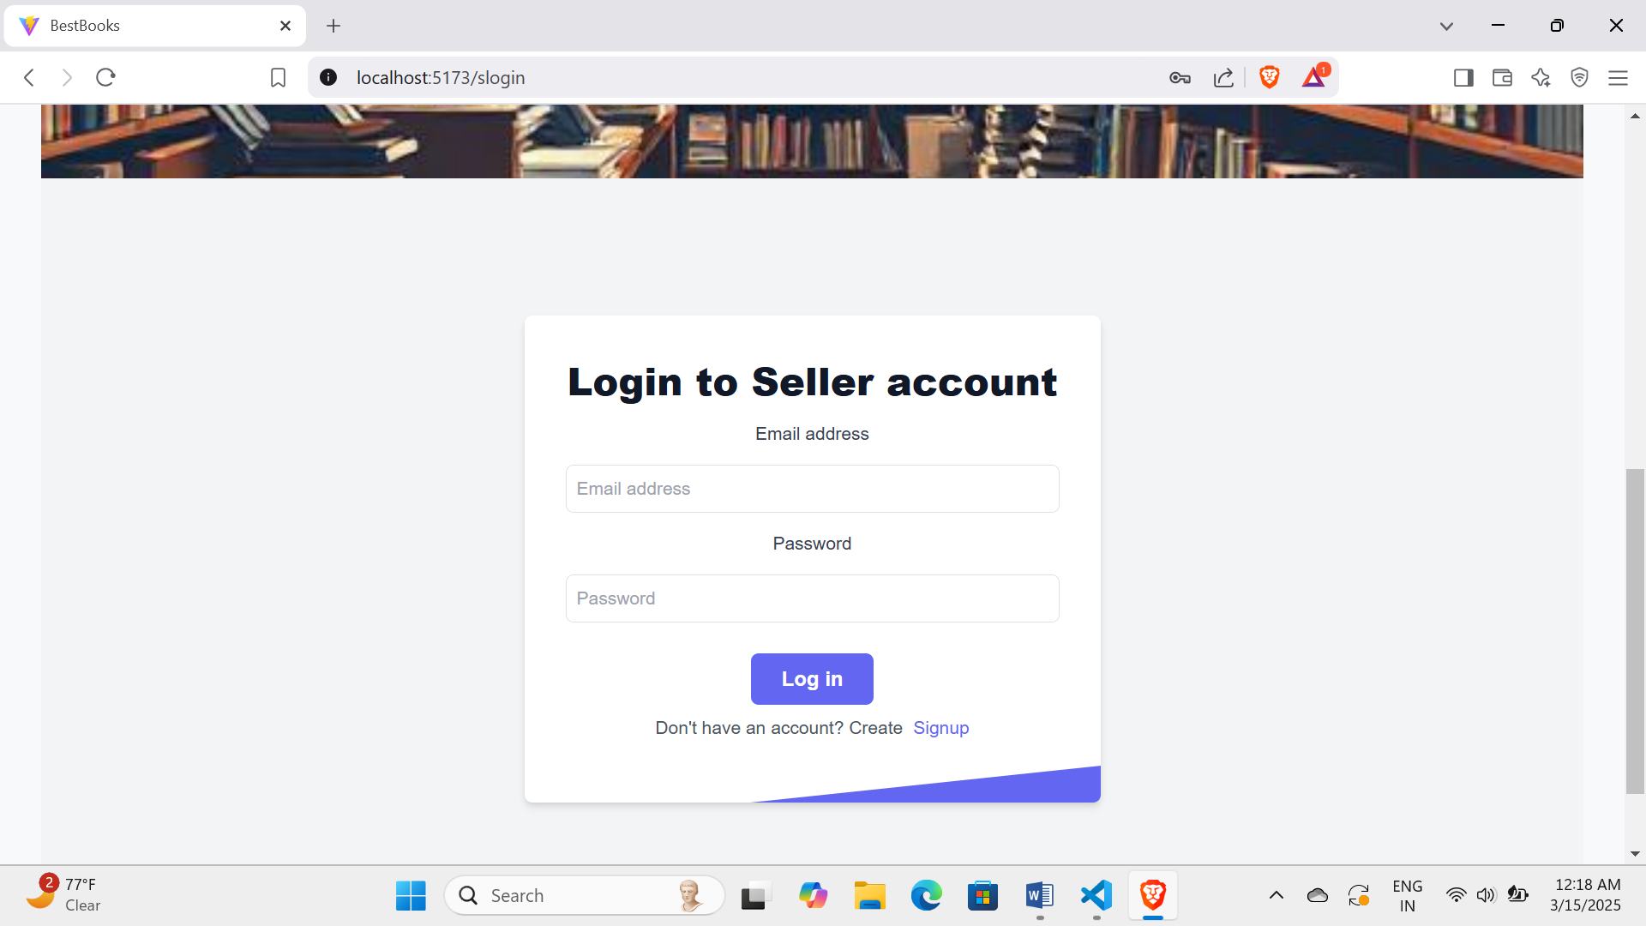

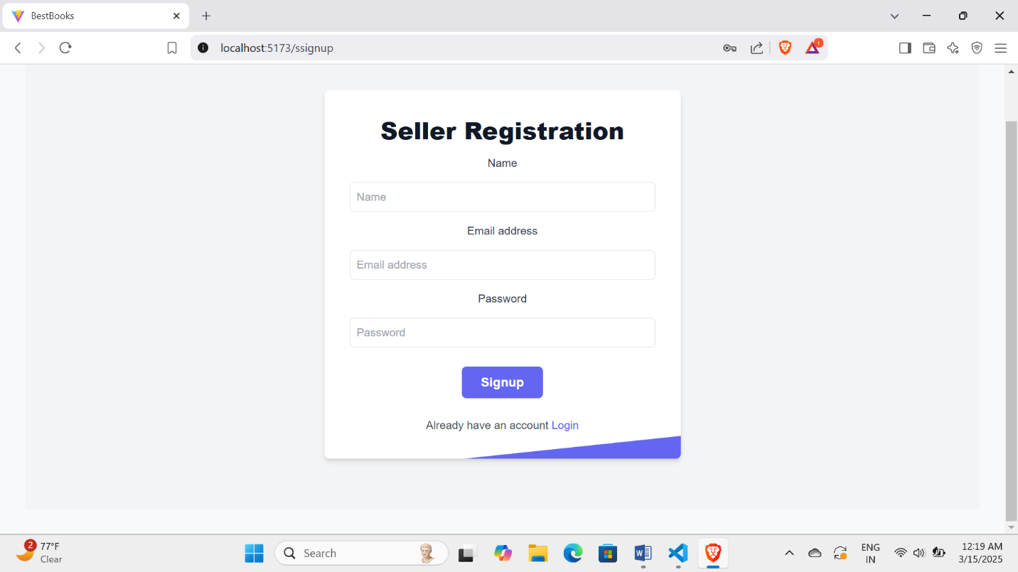

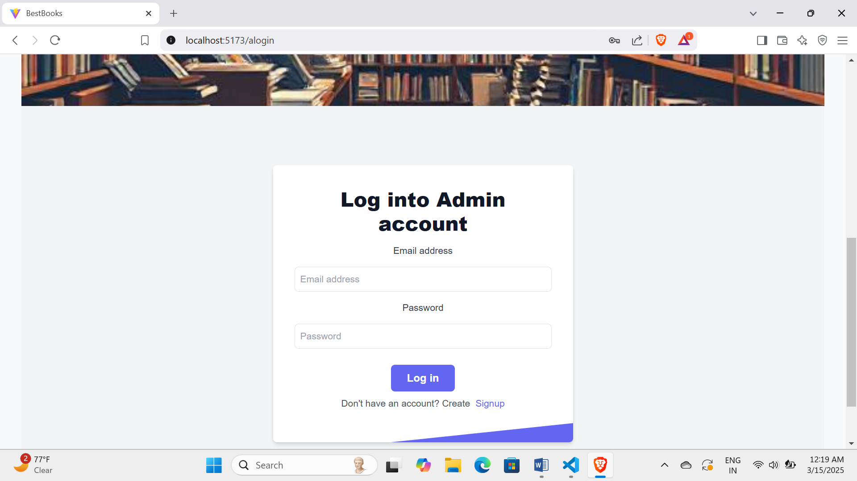

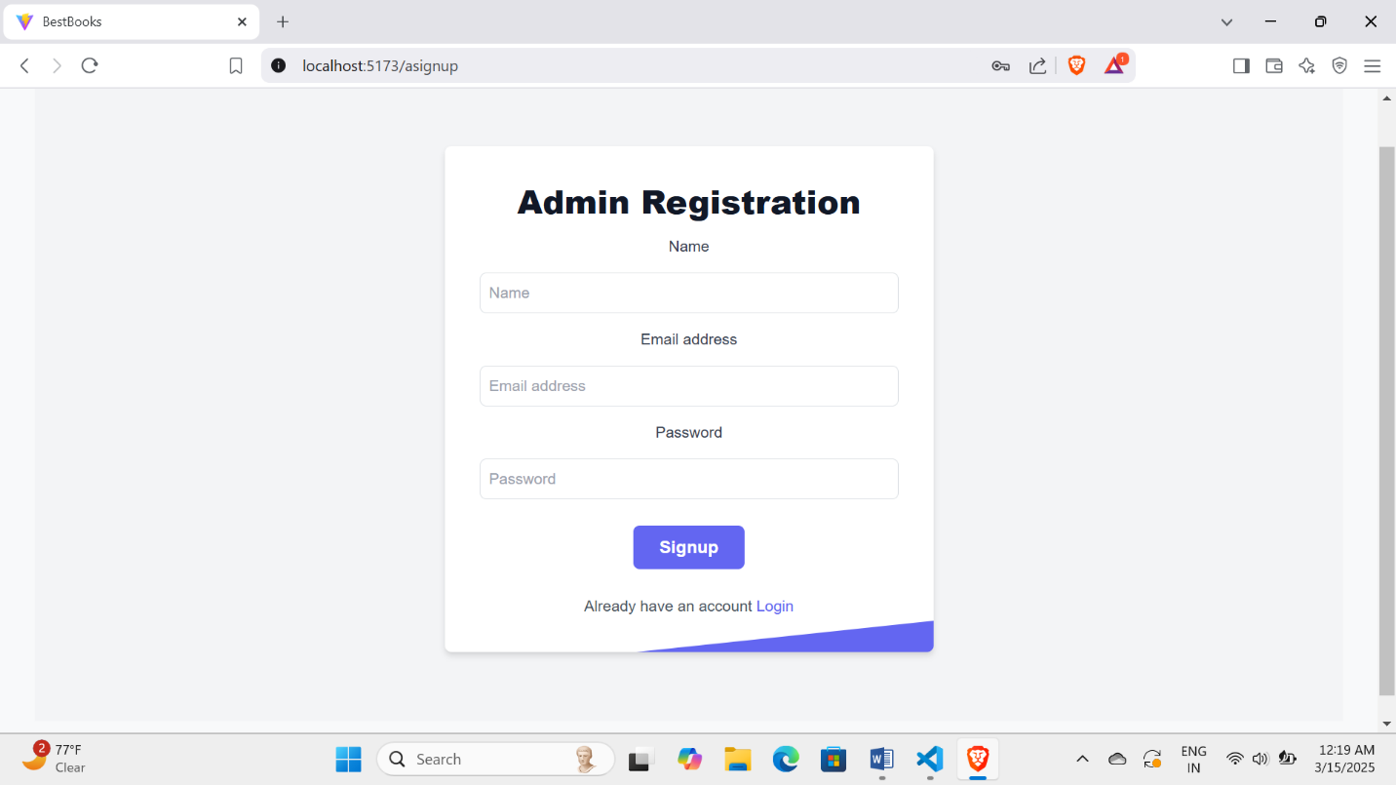

**\*. Future Enhancements:**

**●** This BestBooks book store can be further updated by adding features like:

Recommendations of books according to their past selection taste.

Filtering options to filter the genre as they wanted.

Adding payment methods in the application so that customers can buy books.

Making the books readable in online.

Adding audible feature for books where we can hear and understand without reading it.

**~~~***~~~**